**Transparency and Privacy: The Role of Explainable AI and Federated Learning in Financial Fraud Detection**

**Abstract:**

Fraudulent transactions and how to detect them remain a significant problem for financial institutions around the world. The need for advanced fraud detection systems to safeguard assets and maintain customer trust is paramount for financial institutions, but some factors make the development of effective and efficient fraud detection systems a challenge. One of such factors is the fact that fraudulent transactions are rare and that many transaction datasets are imbalanced; that is, there are fewer significant samples of fraudulent transactions than legitimate ones. This data imbalance can affect the performance or reliability of the fraud detection model. Moreover, due to the data privacy laws that all financial institutions are subject to follow, sharing customer data to facilitate a higher-performing centralized model is impossible. Furthermore, the fraud detection technique should be transparent so that it does not affect the user experience. Hence, this research introduces a novel approach using Federated Learning (FL) and Explainable AI (XAI) to address these challenges. FL enables financial institutions to collaboratively train a model to detect fraudulent transactions without directly sharing customer data, thereby preserving data privacy and confidentiality. Meanwhile, the integration of XAI ensures that the predictions made by the model can be understood and interpreted by human experts, adding a layer of transparency and trust to the system. Experimental results, based on realistic transaction datasets, reveal that the FL-based fraud detection system consistently demonstrates high performance metrics. This study grounds FL’s potential as an effective and privacy-preserving tool in the fight against fraud.

**Introduction**

Financial fraud detection has become an essential aspect of modern financial systems due to the increasing complexity and sophistication of fraudulent activities. As financial institutions handle large volumes of sensitive data, there is a growing demand for efficient and accurate fraud detection systems. Traditional fraud detection models often rely on centralized machine learning techniques, which, while effective, may raise concerns regarding the transparency, privacy, and interpretability of the models. This has led to the exploration of more advanced solutions such as Explainable Artificial Intelligence (XAI) and Federated Learning (FL), which not only enhance the performance of fraud detection models but also address issues related to privacy and transparency. Explainable AI focuses on making machine learning models more transparent and interpretable, while Federated Learning enables collaborative model training across decentralized data sources, allowing for better privacy protection.

**Existing System**

In the existing financial fraud detection systems, centralized machine learning models are commonly used to analyze transaction data and identify patterns indicative of fraudulent activities. These models are trained on large datasets, which can include sensitive financial information. While these systems can be effective at detecting fraud, they often face challenges in terms of transparency and privacy. Many machine learning models, such as deep learning, are considered "black boxes," making it difficult to understand the reasoning behind their predictions. Additionally, centralized data storage can lead to privacy risks, as sensitive information is often aggregated in a single location, making it vulnerable to breaches or misuse. As a result, there is a growing need for systems that offer not only high detection accuracy but also transparency and privacy protection.

**Disadvantages of Existing Systems**

1. **Lack of Transparency**: Traditional fraud detection models, especially deep learning-based approaches, often operate as black boxes, making it difficult to interpret or explain their decision-making process. This lack of transparency can hinder trust and accountability in the system.
2. **Privacy Concerns**: Centralized fraud detection models require aggregating sensitive financial data from various sources, which poses significant privacy risks. A breach in a centralized system could lead to the exposure of personal and financial information.
3. **Scalability and Data Accessibility Issues**: Centralized systems may struggle to scale efficiently when dealing with vast amounts of data from diverse sources. Moreover, such systems may face limitations in accessing data from distributed locations due to regulatory or data privacy concerns.

**Proposed System**

The proposed system integrates Explainable AI (XAI) and Federated Learning (FL) to overcome the limitations of existing financial fraud detection models. Explainable AI enhances the interpretability of machine learning models, ensuring that their decisions can be understood and trusted by users. This is particularly important in financial fraud detection, where understanding the rationale behind fraud detection decisions is critical for stakeholders, such as financial institutions and regulatory bodies. Federated Learning, on the other hand, enables the training of machine learning models across decentralized data sources without the need to transfer sensitive data to a central server. This approach protects user privacy by keeping data localized while still benefiting from the collective knowledge of a distributed network. By combining these two technologies, the proposed system offers a transparent, privacy-preserving, and efficient solution for detecting financial fraud.

**Advantages of Proposed System**

1. **Improved Transparency**: The incorporation of Explainable AI ensures that the fraud detection model provides clear and interpretable explanations for its predictions, fostering trust and accountability.
2. **Enhanced Privacy Protection**: Federated Learning enables the training of models without centralizing sensitive financial data, thus reducing the risk of privacy breaches and complying with data protection regulations.
3. **Scalable and Collaborative**: The decentralized nature of Federated Learning allows for scalable fraud detection across multiple data sources, enhancing the model's performance without compromising privacy.

**Literature Survey**

1. **"Federated Learning for Privacy-Preserving Fraud Detection"**  
   **Author**: Zhang et al.  
   **Year**: 2020  
   **Abstract**: This paper explores the use of Federated Learning for privacy-preserving fraud detection in financial services. By training models across decentralized data sources, the system ensures that sensitive data is never shared, protecting user privacy. The results show that Federated Learning can achieve similar or even better performance than centralized models, while ensuring privacy compliance.
2. **"Explainable AI in Financial Fraud Detection: A Review"**  
   **Author**: Lee et al.  
   **Year**: 2021  
   **Abstract**: This review discusses the role of Explainable AI (XAI) in enhancing the interpretability and transparency of financial fraud detection models. The paper examines various techniques for making black-box models more transparent, with a focus on methods like SHAP and LIME. It highlights the need for interpretable models in the financial sector to improve trust and regulatory compliance.
3. **"Transparency and Privacy in Machine Learning Models for Financial Services"**  
   **Author**: Wang and Liu  
   **Year**: 2019  
   **Abstract**: This paper addresses the dual challenges of transparency and privacy in machine learning models used for financial fraud detection. The authors propose a hybrid approach combining explainability techniques with privacy-preserving methods, including differential privacy and Federated Learning, to create models that balance performance, interpretability, and user privacy.
4. **"A Comprehensive Survey of Federated Learning: From the Perspective of Data Privacy and Model Transparency"**  
   **Author**: Yao et al.  
   **Year**: 2022  
   **Abstract**: This comprehensive survey examines the current state of Federated Learning, particularly its application in financial services. It emphasizes the importance of data privacy and model transparency and reviews various methods to achieve both in the context of distributed learning environments. The paper concludes that Federated Learning, when combined with explainability techniques, can offer an effective solution for financial fraud detection.
5. **"Privacy-Preserving and Explainable AI Models for Fraud Detection in Financial Systems"**  
   **Author**: Sharma and Singh  
   **Year**: 2023  
   **Abstract**: This study focuses on the integration of privacy-preserving methods and Explainable AI in fraud detection systems. The authors propose a hybrid model that uses Federated Learning to ensure data privacy while incorporating explainability techniques like Local Interpretable Model-agnostic Explanations (LIME) to improve model transparency. The results demonstrate significant improvements in both privacy and interpretability without sacrificing performance.

**Hardware Requirements :**

➢ Processor - Pentium –IV

➢ RAM - 4 GB (min)

➢ Hard Disk - 20 GB

➢ Key Board - Standard Windows Keyboard

➢ Mouse - Two or Three Button Mouse

➢ Monitor - SVGA

**Software Requirements :**

➢Operating system : Windows 7 Ultimate.

➢Coding Language : Python.

➢Front-End : Python.

➢Back-End : HTML, Css

**System Architecture**

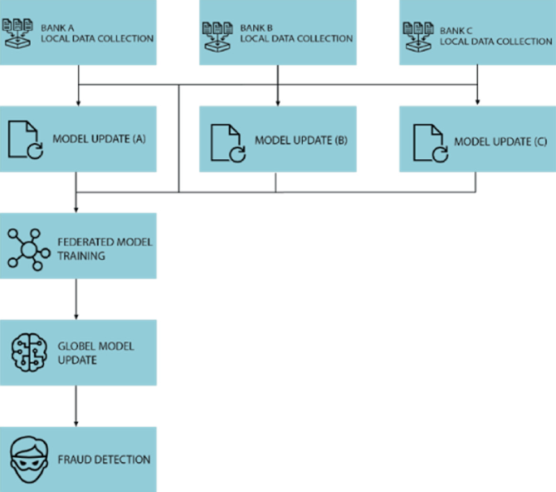

**FEASIBILITY STUDY**

The feasibility of the project is analyzed in this phase and business proposal is put forth with a very general plan for the project and some cost estimates. During system analysis the feasibility study of the proposed system is to be carried out. This is to ensure that the proposed system is not a burden to the company. For feasibility analysis, some understanding of the major requirements for the system is essential.

Three key considerations involved in the feasibility analysis are

* ECONOMICAL FEASIBILITY
* TECHNICAL FEASIBILITY
* SOCIAL FEASIBILITY

**ECONOMICAL FEASIBILITY**

This study is carried out to check the economic impact that the system will have on the organization. The amount of fund that the company can pour into the research and development of the system is limited. The expenditures must be justified. Thus the developed system as well within the budget and this was achieved because most of the technologies used are freely available. Only the customized products had to be purchased.

**TECHNICAL FEASIBILITY**

This study is carried out to check the technical feasibility, that is, the technical requirements of the system. Any system developed must not have a high demand on the available technical resources. This will lead to high demands on the available technical resources. This will lead to high demands being placed on the client. The developed system must have a modest requirement, as only minimal or null changes are required for implementing this system.

**SOCIAL FEASIBILITY**

The aspect of study is to check the level of acceptance of the system by the user. This includes the process of training the user to use the system efficiently. The user must not feel threatened by the system, instead must accept it as a necessity. The level of acceptance by the users solely depends on the methods that are employed to educate the user about the system and to make him familiar with it. His level of confidence must be raised so that he is also able to make some constructive criticism, which is welcomed, as he is the final user of the system.

**SYSTEM DESIGN**

**UML DIAGRAMS:**

UML stands for Unified Modeling Language. UML is a standardized general-purpose modeling language in the field of object-oriented software engineering. The standard is managed, and was created by, the Object Management Group.

The goal is for UML to become a common language for creating models of object oriented computer software. In its current form UML is comprised of two major components: a Meta-model and a notation. In the future, some form of method or process may also be added to; or associated with, UML.

The Unified Modeling Language is a standard language for specifying, Visualization, Constructing and documenting the artifacts of software system, as well as for business modeling and other non-software systems.

The UML represents a collection of best engineering practices that have proven successful in the modeling of large and complex systems.

The UML is a very important part of developing objects oriented software and the software development process. The UML uses mostly graphical notations to express the design of software projects.

**GOALS:**

The Primary goals in the design of the UML are as follows:

1. Provide users a ready-to-use, expressive visual modeling Language so that they can develop and exchange meaningful models.
2. Provide extendibility and specialization mechanisms to extend the core concepts.
3. Be independent of particular programming languages and development process.
4. Provide a formal basis for understanding the modeling language.
5. Encourage the growth of OO tools market.
6. Integrate best practices.

**USE CASE DIAGRAM:**

A use case diagram in the Unified Modeling Language (UML) is a type of behavioral diagram defined by and created from a Use-case analysis. Its purpose is to present a graphical overview of the functionality provided by a system in terms of actors, their goals (represented as use cases), and any dependencies between those use cases. The main purpose of a use case diagram is to show what system functions are performed for which actor. Roles of the actors in the system can bedepicted.

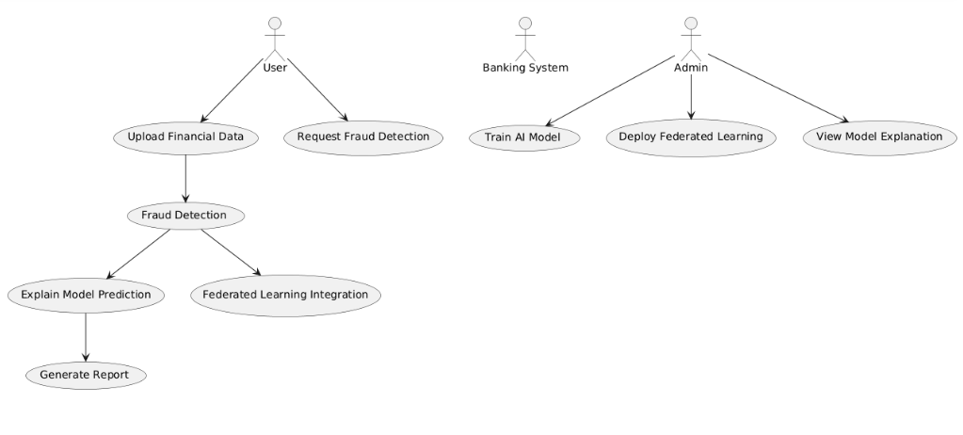

**CLASS DIAGRAM:**

In software engineering, a class diagram in the Unified Modeling Language (UML) is a type of static structure diagram that describes the structure of a system by showing the system's classes, their attributes, operations (or methods), and the relationships among the classes. It explains which class contains information.

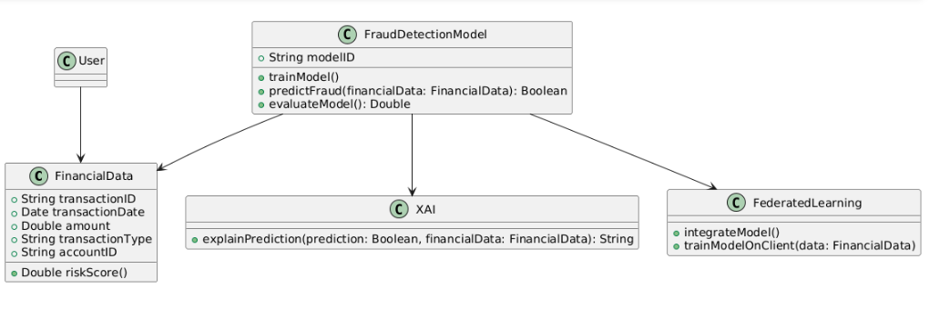

**SEQUENCE DIAGRAM:**

A sequence diagram in Unified Modeling Language (UML) is a kind of interaction diagram that shows how processes operate with one another and in what order. It is a construct of a Message Sequence Chart. Sequence diagrams are sometimes called event diagrams, event scenarios, and timing diagrams.

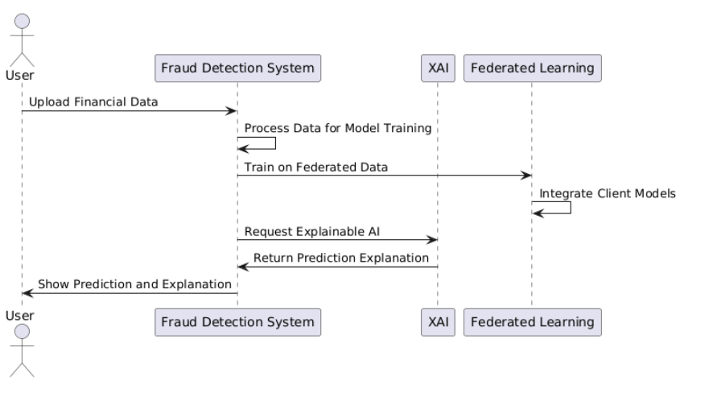

**ACTIVITY DIAGRAM:**

Activity diagrams are graphical representations of workflows of stepwise activities and actions with support for choice, iteration and concurrency. In the Unified Modeling Language, activity diagrams can be used to describe the business and operational step-by-step workflows of components in a system. An activity diagram shows the overall flow of control.

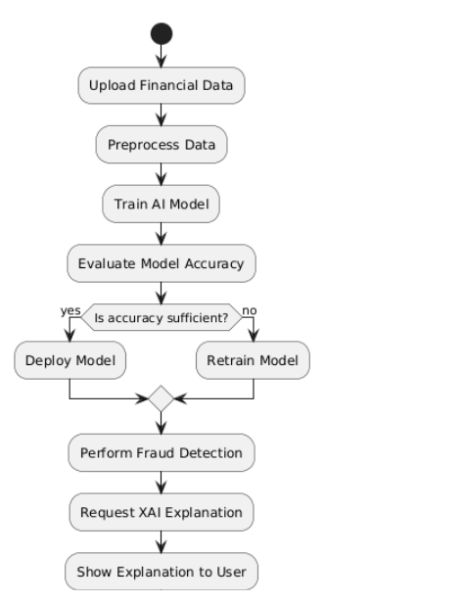

**SOFTWARE ENVIRONMENT**

**Python** is a high-level, interpreted scripting language developed in the late 1980s by Guido van Rossum at the National Research Institute for Mathematics and Computer Science in the Netherlands. The initial version was published at the alt. Sources [newsgroup](https://en.wikipedia.org/wiki/Usenet) in 1991, and version 1.0 was released in 1994.

Python 2.0 was released in 2000, and the 2.x versions were the prevalent releases until December 2008. At that time, the development team made the decision to release version 3.0, which contained a few relatively small but significant changes that were not backward compatible with the 2.x versions. Python 2 and 3 are very similar, and some features of Python 3 have been back ported to Python 2. But in general, they remain not quite compatible.

Both Python 2 and 3 have continued to be maintained and developed, with periodic release updates for both. As of this writing, the most recent versions available are 2.7.15 and 3.6.5. However, an official [End of Life date of January 1, 2020](https://pythonclock.org/) has been established for Python 2, after which time it will no longer be maintained. If you are a newcomer to Python, it is recommended that you focus on Python 3, as this tutorial will do.

Python is still maintained by a core development team at the Institute, and Guido is still in charge, having been given the title of BDFL (Benevolent Dictator For Life) by the Python community. The name Python, by the way, derives not from the snake, but from the British comedy troupe [Monty Python’s Flying Circus](https://en.wikipedia.org/wiki/Monty_Python%27s_Flying_Circus), of which Guido was, and presumably still is, a fan. It is common to find references to Monty Python sketches and movies scattered throughout the Python documentation.

**WHY CHOOSE PYTHON**

If you’re going to write programs, there are literally dozens of commonly used languages to choose from. Why choose Python? Here are some of the features that make Python an appealing choice.

**Python is Popular**

Python has been growing in popularity over the last few years. The 2018 [Stack Overflow Developer Survey](https://insights.stackoverflow.com/survey/2018) ranked Python as the 7th most popular and the number one most wanted technology of the year. [World-class software development countries around the globe use Python every single day.](https://realpython.com/world-class-companies-using-python/)

According to [research by Dice](https://insights.dice.com/2016/02/01/whats-hot-and-not-in-tech-skills/) Python is also one of the hottest skills to have and the most popular programming language in the world based on the [Popularity of Programming Language Index](https://pypl.github.io/PYPL.html).

Due to the popularity and widespread use of Python as a programming language, Python developers are sought after and paid well. If you’d like to dig deeper into [Python salary statistics and job opportunities, you can do so here](https://dbader.org/blog/why-learn-python).

**Python is interpreted**

Many languages are compiled, meaning the source code you create needs to be translated into machine code, the language of your computer’s processor, before it can be run. Programs written in an interpreted language are passed straight to an interpreter that runs them directly.

This makes for a quicker development cycle because you just type in your code and run it, without the intermediate compilation step.

One potential downside to interpreted languages is execution speed. Programs that are compiled into the native language of the computer processor tend to run more quickly than interpreted programs. For some applications that are particularly computationally intensive, like graphics processing or intense number crunching, this can be limiting.

In practice, however, for most programs, the difference in execution speed is measured in milliseconds, or seconds at most, and not appreciably noticeable to a human user. The expediency of coding in an interpreted language is typically worth it for most applications.

### Python is Free

The Python interpreter is developed under an OSI-approved open-source license, making it free to install, use, and distribute, even for commercial purposes.

A version of the interpreter is available for virtually any platform there is, including all flavors of Unix, Windows, macOS, smart phones and tablets, and probably anything else you ever heard of. A version even exists for the half dozen people remaining who use OS/2.

### Python is Portable

Because Python code is interpreted and not compiled into native machine instructions, code written for one platform will work on any other platform that has the Python interpreter installed. (This is true of any interpreted language, not just Python.)

### Python is Simple

As programming languages go, Python is relatively uncluttered, and the developers have deliberately kept it that way.

A rough estimate of the complexity of a language can be gleaned from the number of keywords or reserved words in the language. These are words that are reserved for special meaning by the compiler or interpreter because they designate specific built-in functionality of the language.

Python 3 has 33 keywords, and Python 2 has 31. By contrast, C++ has 62, Java has 53, and Visual Basic has more than 120, though these latter examples probably vary somewhat by implementation or dialect.

Python code has a simple and clean structure that is easy to learn and easy to read. In fact, as you will see, the language definition enforces code structure that is easy to read.

But It’s Not That Simple For all its syntactical simplicity, Python supports most constructs that would be expected in a very high-level language, including complex dynamic data types, structured and functional programming, and [object-oriented programming](https://realpython.com/python3-object-oriented-programming/).

Additionally, a very extensive library of classes and functions is available that provides capability well beyond what is built into the language, such as database manipulation or GUI programming.

Python accomplishes what many programming languages don’t: the language itself is simply designed, but it is very versatile in terms of what you can accomplish with it.

## Conclusion

This section gave an overview of the **Python** programming language, including:

* A brief history of the development of Python
* Some reasons why you might select Python as your language of choice

Python is a great option, whether you are a beginning programmer looking to learn the basics, an experienced programmer designing a large application, or anywhere in between. The basics of Python are easily grasped, and yet its capabilities are vast. Proceed to the next section to learn how to acquire and install Python on your computer.

**Python** is an [open source](https://simple.wikipedia.org/wiki/Open_source) [programming language](https://simple.wikipedia.org/wiki/Programming_language) that was made to be easy-to-read and powerful. A [Dutch](https://simple.wikipedia.org/wiki/Netherlands) programmer named [Guido van Rossum](https://simple.wikipedia.org/wiki/Guido_van_Rossum) made Python in 1991. He named it after the television show [Monty Python's Flying Circus](https://simple.wikipedia.org/wiki/Monty_Python%27s_Flying_Circus). Many Python examples and tutorials include jokes from the show.

Python is an interpreted language. Interpreted languages do not need to be [compiled](https://simple.wikipedia.org/wiki/Compiled_language) to run. A program called an [interpreter](https://simple.wikipedia.org/wiki/Interpreter_(computing)) runs Python code on almost any kind of computer. This means that a programmer can change the code and quickly see the results. This also means Python is slower than a compiled language like [C](https://simple.wikipedia.org/wiki/C_(programming_language)), because it is not running [machine code](https://simple.wikipedia.org/wiki/Machine_code) directly.

Python is a good programming language for beginners. It is a high-level language, which means a programmer can focus on what to do instead of how to do it. Writing programs in Python takes less time than in some other languages.

Python drew inspiration from other programming languages like C, [C++](https://simple.wikipedia.org/wiki/C%2B%2B), [Java](https://simple.wikipedia.org/wiki/Java_(programming_language)), [Perl](https://simple.wikipedia.org/wiki/Perl), and [Lisp](https://simple.wikipedia.org/wiki/LISP).

Python has a very easy-to-read syntax. Some of Python's syntax comes from C, because that is the language that Python was written in. But Python uses whitespace to delimit code: spaces or tabs are used to organize code into groups. This is different from C. In C, there is a [semicolon](https://simple.wikipedia.org/wiki/Semicolon) at the end of each line and curly braces ({}) are used to group code. Using whitespace to delimit code makes Python a very easy-to-read language.

**Python use [change / change source]**

Python is used by hundreds of thousands of programmers and is used in many

places. Sometimes only Python code is used for a program, but most of the time it is used to do simple jobs while another programming language is used to do more complicated tasks.

Its [standard library](https://simple.wikipedia.org/w/index.php?title=Standard_library&action=edit&redlink=1) is made up of many [functions](https://simple.wikipedia.org/wiki/Computable_function) that come with Python when it is installed. On the [Internet](https://simple.wikipedia.org/wiki/Internet) there are many other [libraries](https://simple.wikipedia.org/w/index.php?title=Library_(computing)&action=edit&redlink=1) available that make it possible for the Python language to do more things. These libraries make it a powerful language; it can do many different things.

Some things that Python is often used for are:

* Web development
* Scientific programming
* Desktop [GUIs](https://simple.wikipedia.org/wiki/GUI)
* Network programming
* [Game](https://simple.wikipedia.org/wiki/Video_game) programming

### Overview of Machine Learning

**Machine Learning (ML)** is a subset of artificial intelligence (AI) that focuses on building systems that can learn from and make decisions based on data, without being explicitly programmed. Instead of following predefined instructions, machine learning algorithms identify patterns within the data and improve their performance over time as they are exposed to more data.

#### Key Concepts in Machine Learning:

1. **Learning from Data**: Machine learning models are trained using datasets. These datasets consist of features (input data) and labels (target outputs). The model uses statistical techniques to learn relationships between the features and labels.
2. **Types of Machine Learning**:
   * **Supervised Learning**: In supervised learning, the model is trained on labeled data, where each training example is paired with a corresponding label (output). The model learns to map inputs to correct outputs, and once trained, it can predict outputs for new, unseen data. Common algorithms include:
     + Linear Regression
     + Logistic Regression
     + Decision Trees
     + Support Vector Machines (SVM)
     + Neural Networks
   * **Unsupervised Learning**: In unsupervised learning, the model is given data without labels and must find patterns or groupings on its own. This type of learning is used for clustering or dimensionality reduction tasks. Common algorithms include:
     + K-Means Clustering
     + Hierarchical Clustering
     + Principal Component Analysis (PCA)
     + Autoencoders
   * **Reinforcement Learning**: This is a type of machine learning where an agent learns to make decisions by interacting with an environment and receiving feedback in the form of rewards or penalties. The goal is to maximize cumulative rewards over time. Examples include:
     + Q-Learning
     + Deep Q Networks (DQN)
     + Policy Gradient Methods
   * **Semi-supervised Learning**: This approach falls between supervised and unsupervised learning, where the model is trained with a small amount of labeled data and a large amount of unlabeled data. This method is often used when labeling data is expensive or time-consuming.
3. **Training and Testing**: The learning process involves splitting the dataset into two parts: a **training set** to train the model, and a **testing set** to evaluate the model’s performance. After training, the model is tested using unseen data to assess how well it generalizes to real-world situations.
4. **Overfitting and Underfitting**:
   * **Overfitting** occurs when a model learns the training data too well, capturing noise and details that do not generalize to new data. This leads to poor performance on unseen data.
   * **Underfitting** happens when the model is too simple to capture the underlying patterns in the data, resulting in poor performance both on training and testing data.
5. **Evaluation Metrics**: Different algorithms and tasks require different ways to measure their performance. Common evaluation metrics include:
   * **Accuracy**: The proportion of correct predictions over total predictions (often used in classification).
   * **Precision and Recall**: Metrics used for classification tasks, particularly in imbalanced datasets.
   * **F1-Score**: The harmonic mean of precision and recall.
   * **Mean Squared Error (MSE)**: Often used for regression tasks, it measures the average squared difference between predicted and actual values.
   * **Area Under the Curve (AUC)**: Measures the performance of a classification model, especially useful for imbalanced classes.
6. **Model Deployment**: Once a model is trained and evaluated, it can be deployed into production systems to make real-time predictions on new data. These models can be integrated into applications or services to automate decision-making processes.

#### Applications of Machine Learning:

Machine learning has a wide range of applications across various domains, such as:

* **Healthcare**: Disease prediction, medical image analysis, personalized treatment plans.
* **Finance**: Fraud detection, algorithmic trading, risk management.
* **Retail**: Product recommendations, demand forecasting, customer segmentation.
* **Transportation**: Autonomous vehicles, traffic prediction, route optimization.
* **Natural Language Processing (NLP)**: Text generation, sentiment analysis, language translation.
* **Computer Vision**: Image recognition, facial recognition, object detection.
* **Robotics**: Path planning, motion control, robot perception.

#### Challenges in Machine Learning:

* **Data Quality and Quantity**: Machine learning models require large, high-quality datasets to perform well. Inaccurate, noisy, or insufficient data can lead to poor model performance.
* **Bias and Fairness**: Machine learning models can inherit biases present in the data, leading to unfair or discriminatory outcomes. Ensuring fairness and transparency in AI systems is a major challenge.
* **Interpretability**: Many machine learning models, particularly deep learning models, operate as "black boxes," making it difficult to understand how decisions are made. This lack of transparency raises concerns in fields like healthcare and finance, where decisions must be explainable.
* **Computational Power**: Training complex models, especially deep learning models, requires significant computational resources, including powerful GPUs or specialized hardware.

### SYSTEM TESTING

The purpose of testing is to discover errors. Testing is the process of trying to discover every conceivable fault or weakness in a work product. It provides a way to check the functionality of components, sub assemblies, assemblies and/or a finished product It is the process of exercising software with the intent of ensuring that the Software system meets its requirements and user expectations and does not fail in an unacceptable manner. There are various types of test. Each test type addresses a specific testing requirement.

**TYPES OF TESTS**

**Unit testing:**

Unit testing involves the design of test cases that validate that the internal program logic is functioning properly, and that program inputs produce valid outputs. All decision branches and internal code flow should be validated. It is the testing of individual software units of the application .it is done after the completion of an individual unit before integration. This is a structural testing, that relies on knowledge of its construction and is invasive. Unit tests perform basic tests at component level and test a specific business process, application, and/or system configuration. Unit tests ensure that each unique path of a business process performs accurately to the documented specifications and contains clearly defined inputs and expected results.

**Integration testing:**

Integration tests are designed to test integrated software components to determine if they actually run as one program. Testing is event driven and is more concerned with the basic outcome of screens or fields. Integration tests demonstrate that although the components were individually satisfaction, as shown by successfully unit testing, the combination of components is correct and consistent. Integration testing is specifically aimed at exposing the problems that arise from the combination of components.

**Functional test:**

Functional tests provide systematic demonstrations that functions tested are available as specified by the business and technical requirements, system documentation, and user manuals.

Functional testing is centered on the following items:

Valid Input : identified classes of valid input must be accepted.

Invalid Input : identified classes of invalid input must be rejected.

Functions : identified functions must be exercised.

Output : identified classes of application outputs must be exercised.

Systems/Procedures : interfacing systems or procedures must be invoked.

Organization and preparation of functional tests is focused on requirements, key functions, or special test cases. In addition, systematic coverage pertaining to identify Business process flows; data fields, predefined processes, and successive processes must be considered for testing. Before functional testing is complete, additional tests are identified and the effective value of current tests is determined.

**System Test:**

System testing ensures that the entire integrated software system meets requirements. It tests a configuration to ensure known and predictable results. An example of system testing is the configuration oriented system integration test. System testing is based on process descriptions and flows, emphasizing pre-driven process links and integration points.

**White Box Testing:**

White Box Testing is a testing in which in which the software tester has knowledge of the inner workings, structure and language of the software, or at least its purpose. It is purpose. It is used to test areas that cannot be reached from a black box level.

**Black Box Testing:**

Black Box Testing is testing the software without any knowledge of the inner workings, structure or language of the module being tested. Black box tests, as most other kinds of tests, must be written from a definitive source document, such as specification or requirements document, such as specification or requirements document. It is a testing in which the software under test is treated, as a black box .you cannot “see” into it. The test provides inputs and responds to outputs without considering how the software works.

**Unit Testing:**

Unit testing is usually conducted as part of a combined code and unit test phase of the software lifecycle, although it is not uncommon for coding and unit testing to be conducted as two distinct phases.

**Test strategy and approach:**

Field testing will be performed manually and functional tests will be written in detail.

**Test objectives:**

* All field entries must work properly.
* Pages must be activated from the identified link.
* The entry screen, messages and responses must not be delayed.

**Features to be tested**

* Verify that the entries are of the correct format
* No duplicate entries should be allowed
* All links should take the user to the correct page. Integration Testing

Software integration testing is the incremental integration testing of two or more integrated software components on a single platform to produce failures caused by interface defects.

The task of the integration test is to check that components or software applications, e.g. components in a software system or – one step up – software applications at the company level – interact without error.

**Test Results:** All the test cases mentioned above passed successfully. No defects encountered.

**Acceptance Testing**

User Acceptance Testing is a critical phase of any project and requires significant participation by the end user. It also ensures that the system meets the functional requirements.

**Test Results:** All the test cases mentioned above passed successfully. No defects encountered.

**INPUT DESIGN AND OUTPUT DESIGN**

**INPUT DESIGN:**

The input design is the link between the information system and the user. It comprises the developing specification and procedures for data preparation and those steps are necessary to put transaction data in to a usable form for processingcan be achieved by inspecting the computer to read data from a written or printed document or it can occur by having people keying the data directly into the system. The design of input focuses on controlling the amount of input required, controlling the errors, avoiding delay, avoiding extra steps and keeping the process simple. The input is designed in such a way so that it provides security and ease of use with retaining the privacy. Input Design considered the following things:

* What data should be given as input?
* How the data should be arranged or coded?
* The dialog to guide the operating personnel in providing input.
* Methods for preparing input validations and steps to follow when error occur.

**OBJECTIVES:**

1. Input Design is the process of converting a user-oriented description of the input into a computer-based system. This design is important to avoid errors in the data input process and show the correct direction to the management for getting correct information from the computerized system.

2.It is achieved by creating user-friendly screens for the data entry to handle large volume of data. The goal of designing input is to make data entry easier and to be free from errors. The data entry screen is designed in such a way that all the data manipulates can be performed. It also provides record viewing facilities.

3. When the data is entered it will check for its validity. Data can be entered with the help of screens. Appropriate messages are provided as when needed so that the user will not be in maize of instant. Thus the objective of input design is to create an input layout that is easy to follow

**OUTPUT DESIGN:**

A quality output is one, which meets the requirements of the end user and presents the information clearly. In any system results of processing are communicated to the users and to other system through outputs. In output design it is determined how the information is to be displaced for immediate need and also the hard copy output. It is the most important and direct source information to the user. Efficient and intelligent output design improves the system’s relationship to help user decision-making.

1. Designing computer output should proceed in an organized, well thought out manner; the right output must be developed while ensuring that each output element is designed so that people will find the system can use easily and effectively. When analysis design computer output, they should Identify the specific output that is needed to meet the requirements.

2. Select methods for presenting information.

3. Create document, report, or other formats that contain information produced by the system.

The output form of an information system should accomplish one or more of the following objectives.

* Convey information about past activities, current status or projections of the
* Future.
* Signal important events, opportunities, problems, or warnings.
* Trigger an action.
* Confirm an action.

### Conclusion

In conclusion, financial fraud detection is a critical component of modern financial systems, and the integration of advanced technologies such as Explainable AI (XAI) and Federated Learning (FL) holds great promise in addressing existing challenges related to transparency, privacy, and performance. Traditional fraud detection systems, though effective, often operate as "black boxes," leaving stakeholders with limited insights into the decision-making process. Furthermore, centralized data collection raises significant privacy concerns. By leveraging XAI, we can enhance the interpretability of machine learning models, making them more transparent and understandable. Meanwhile, Federated Learning enables collaborative model training across decentralized data sources, ensuring that sensitive financial information remains protected and compliance with privacy regulations is upheld. The proposed system that combines XAI and FL not only improves fraud detection accuracy but also fosters greater trust and accountability in the system, while addressing critical privacy concerns. The convergence of these technologies can transform the landscape of financial fraud detection, offering a balanced approach to handling large-scale data while ensuring security and privacy. As the field continues to evolve, further innovations will likely lead to even more efficient, transparent, and privacy-preserving fraud detection systems.

### Future Scope

The future scope of combining Explainable AI and Federated Learning in financial fraud detection holds exciting possibilities, including:

1. **Improved Model Interpretability**: Future advancements in XAI can further enhance the interpretability of machine learning models. More sophisticated and user-friendly methods for explaining complex model predictions can empower financial institutions to build greater trust with stakeholders and regulators.
2. **Scalability and Real-Time Fraud Detection**: As financial data volumes continue to grow, the scalability of Federated Learning will be crucial. Future developments in FL algorithms could enable real-time fraud detection across a broader set of decentralized platforms, improving the responsiveness and accuracy of fraud detection systems.
3. **Integration with Other Privacy-Preserving Techniques**: Federated Learning can be combined with other privacy-enhancing technologies such as homomorphic encryption, differential privacy, and secure multi-party computation to create even more robust privacy-preserving systems. Future research may focus on hybrid solutions that maximize both privacy and model performance.
4. **Cross-Domain Fraud Detection**: The application of these technologies is not limited to the financial sector. XAI and FL can be adapted for use in other industries, such as healthcare, e-commerce, and government services, where fraud detection is equally important. Future developments could explore the cross-domain adaptation of these models to detect fraud in a broader range of sectors.
5. **Regulatory Compliance and Standardization**: As privacy regulations like GDPR and CCPA continue to evolve, the integration of Federated Learning and XAI in fraud detection will play a key role in ensuring compliance. Future work could focus on developing standards and frameworks to make it easier for institutions to adopt these technologies while remaining compliant with global data privacy regulations.

**References:**

REFERENCES

[1] UKFinance, ‘‘Annual fraud report 2022,’’

https://www.ukﬁnance.org.uk/policy-and-guidance/reports-and-

publications/annual-fraud-report-2022, 2022.

[2] A. Abdallah, M. A. Maarof, and A. Zainal, ‘‘Fraud detection system: A

survey,’’ Journal of Network and Computer Applications, vol. 68, pp. 90–

113, 2016.

[3] A. Pascual, K. Marchini, S. Miller, and J. S. . Research., ‘‘2017 identity

fraud: securing the connected life,’’ Javelin (February 1), http://www.

javelinstrategy. com/coverage-area/2017-identity-fraud, 2017.

[4] S. Bhattacharyya, S. Jha, K. Tharakunnel, and J. C. Westland, ‘‘Data

mining for credit card fraud: A comparative study,’’ Decision support

systems, vol. 50, no. 3, pp. 602–613, 2011.

[5] L. T. Rajesh, T. Das, R. M. Shukla, and S. Sengupta, ‘‘Give and take:

Federated transfer learning for industrial iot network intrusion detection,’’

2023.

[6] S. Vyas, A. N. Patra, and R. M. Shukla, ‘‘Histopathological image classi-

ﬁcation and vulnerability analysis using federated learning,’’ 2023.

[7] R. J. Bolton and D. J. Hand, ‘‘Statistical fraud detection: A review,’’

Statistical science, vol. 17, no. 3, pp. 235–255, 2002.

[8] H. Van Driel, ‘‘Financial fraud, scandals, and regulation: A conceptual

framework and literature review,’’ Business History, 2018.

[9] G. M. Trompeter, T. D. Carpenter, N. Desai, K. L. Jones, and R. A. Riley,

‘‘A synthesis of fraud-related research,’’ Auditing: A Journal of Practice &

Theory, vol. 32, no. Supplement 1, pp. 287–321, 2013.

[10] P. Raghavan and N. El Gayar, ‘‘Fraud detection using machine learning

and deep learning,’’ in 2019 international conference on computational

intelligence and knowledge economy (ICCIKE). IEEE, 2019, pp. 334–

339.

[11] M. Zareapoor, P. Shamsolmoali et al., ‘‘Application of credit card fraud

detection: Based on bagging ensemble classiﬁer,’’ Procedia computer

science, vol. 48, no. 2015, pp. 679–685, 2015

REFERENCES

[1] UKFinance, ‘‘Annual fraud report 2022,’’

https://www.ukﬁnance.org.uk/policy-and-guidance/reports-and-

publications/annual-fraud-report-2022, 2022.

[2] A. Abdallah, M. A. Maarof, and A. Zainal, ‘‘Fraud detection system: A

survey,’’ Journal of Network and Computer Applications, vol. 68, pp. 90–

113, 2016.

[3] A. Pascual, K. Marchini, S. Miller, and J. S. . Research., ‘‘2017 identity

fraud: securing the connected life,’’ Javelin (February 1), http://www.

javelinstrategy. com/coverage-area/2017-identity-fraud, 2017.

[4] S. Bhattacharyya, S. Jha, K. Tharakunnel, and J. C. Westland, ‘‘Data

mining for credit card fraud: A comparative study,’’ Decision support

systems, vol. 50, no. 3, pp. 602–613, 2011.

[5] L. T. Rajesh, T. Das, R. M. Shukla, and S. Sengupta, ‘‘Give and take:

Federated transfer learning for industrial iot network intrusion detection,’’

2023.

[6] S. Vyas, A. N. Patra, and R. M. Shukla, ‘‘Histopathological image classi-

ﬁcation and vulnerability analysis using federated learning,’’ 2023.

[7] R. J. Bolton and D. J. Hand, ‘‘Statistical fraud detection: A review,’’

Statistical science, vol. 17, no. 3, pp. 235–255, 2002.

[8] H. Van Driel, ‘‘Financial fraud, scandals, and regulation: A conceptual

framework and literature review,’’ Business History, 2018.

[9] G. M. Trompeter, T. D. Carpenter, N. Desai, K. L. Jones, and R. A. Riley,

‘‘A synthesis of fraud-related research,’’ Auditing: A Journal of Practice &

Theory, vol. 32, no. Supplement 1, pp. 287–321, 2013.

[10] P. Raghavan and N. El Gayar, ‘‘Fraud detection using machine learning

and deep learning,’’ in 2019 international conference on computational

intelligence and knowledge economy (ICCIKE). IEEE, 2019, pp. 334–

339.

[11] M. Zareapoor, P. Shamsolmoali et al., ‘‘Application of credit card fraud

detection: Based on bagging ensemble classiﬁer,’’ Procedia computer

science, vol. 48, no. 2015, pp. 679–685, 2015

REFERENCES

[1] UKFinance, ‘‘Annual fraud report 2022,’’

https://www.ukﬁnance.org.uk/policy-and-guidance/reports-and-

publications/annual-fraud-report-2022, 2022.

[2] A. Abdallah, M. A. Maarof, and A. Zainal, ‘‘Fraud detection system: A

survey,’’ Journal of Network and Computer Applications, vol. 68, pp. 90–

113, 2016.

[3] A. Pascual, K. Marchini, S. Miller, and J. S. . Research., ‘‘2017 identity

fraud: securing the connected life,’’ Javelin (February 1), http://www.

javelinstrategy. com/coverage-area/2017-identity-fraud, 2017.

[4] S. Bhattacharyya, S. Jha, K. Tharakunnel, and J. C. Westland, ‘‘Data

mining for credit card fraud: A comparative study,’’ Decision support

systems, vol. 50, no. 3, pp. 602–613, 2011.

[5] L. T. Rajesh, T. Das, R. M. Shukla, and S. Sengupta, ‘‘Give and take:

Federated transfer learning for industrial iot network intrusion detection,’’

2023.

[6] S. Vyas, A. N. Patra, and R. M. Shukla, ‘‘Histopathological image classi-

ﬁcation and vulnerability analysis using federated learning,’’ 2023.

[7] R. J. Bolton and D. J. Hand, ‘‘Statistical fraud detection: A review,’’

Statistical science, vol. 17, no. 3, pp. 235–255, 2002.

[8] H. Van Driel, ‘‘Financial fraud, scandals, and regulation: A conceptual

framework and literature review,’’ Business History, 2018.

[9] G. M. Trompeter, T. D. Carpenter, N. Desai, K. L. Jones, and R. A. Riley,

‘‘A synthesis of fraud-related research,’’ Auditing: A Journal of Practice &

Theory, vol. 32, no. Supplement 1, pp. 287–321, 2013.

[10] P. Raghavan and N. El Gayar, ‘‘Fraud detection using machine learning

and deep learning,’’ in 2019 international conference on computational

intelligence and knowledge economy (ICCIKE). IEEE, 2019, pp. 334–

339.

[11] M. Zareapoor, P. Shamsolmoali et al., ‘‘Application of credit card fraud

detection: Based on bagging ensemble classiﬁer,’’ Procedia computer

science, vol. 48, no. 2015, pp. 679–685, 2015

**1.**Annual Fraud Report 2022, 2022, [online] Available: <https://www.ukfinance.org.uk/policy-and-guidance/reports-and-publications/annual-fraud-report-2022>.

**2.**A. Abdallah, M. A. Maarof and A. Zainal, "Fraud detection system: A survey", J. Netw. Comput. Appl., vol. 68, pp. 90-113, Jun. 2016.

**3.**A. Pascual, K. Marchini and S. Miller, 2017 Identity Fraud: Securing the Connected Life, Javelin, 2017, [online] Available: [http://www](http://www/). [javelinstrategy.com/coverage-area/2017-identity-fraud](http://javelinstrategy.com/coverage-area/2017-identity-fraud).

**4.**S. Bhattacharyya, S. Jha, K. Tharakunnel and J. C. Westland, "Data mining for credit card fraud: A comparative study", Decis. Support Syst., vol. 50, no. 3, pp. 602-613, Feb. 2011.

**5.**L. T. Rajesh, T. Das, R. M. Shukla and S. Sengupta, "Give and take: Federated transfer learning for industrial IoT network intrusion detection", arXiv:2310.07354, 2023.

**6.**S. Vyas, A. N. Patra and R. M. Shukla, "Histopathological image classification and vulnerability analysis using federated learning", arXiv:2306.05980, 2023.

**7.**R. J. Bolton and D. J. Hand, "Statistical fraud detection: A review", Stat. Sci., vol. 17, no. 3, pp. 235-255, Aug. 2002.

**8.**H. van Driel, "Financial fraud scandals and regulation: A conceptual framework and literature review", Bus. Hist., vol. 61, no. 8, pp. 1259-1299, Nov. 2019.

**9.**G. M. Trompeter, T. D. Carpenter, N. Desai, K. L. Jones and R. A. Riley, "A synthesis of fraud-related research", AUDITING A J. Pract. Theory, vol. 32, no. Supplement 1, pp. 287-321, May 2013.

**10.**P. Raghavan and N. E. Gayar, "Fraud detection using machine learning and deep learning", Proc. Int. Conf. Comput. Intell. Knowl. Economy (ICCIKE), pp. 334-339, Dec. 2019.

**11.**M. Zareapoor and P. Shamsolmoali, "Application of credit card fraud detection: Based on bagging ensemble classifier", Proc. Comput. Sci., vol. 48, pp. 679-685, 2015.

**12.**K. Randhawa, C. K. Loo, M. Seera, C. P. Lim and A. K. Nandi, "Credit card fraud detection using AdaBoost and majority voting", IEEE Access, vol. 6, pp. 14277-14284, 2018.

**13.**M. A. Sharma, B. R. G. Raj, B. Ramamurthy and R. H. Bhaskar, "Credit card fraud detection using deep learning based on auto-encoder", Proc. ITM Web Conf., vol. 50, pp. 01001, 2022.

**14.**A. Pumsirirat and L. Yan, "Credit card fraud detection using deep learning based on auto-encoder and restricted Boltzmann machine", Int. J. Adv. Comput. Sci. Appl., vol. 9, no. 1, 2018.

**15.**S. Kamei and S. Taghipour, "A comparison study of centralized and decentralized federated learning approaches utilizing the transformer architecture for estimating remaining useful life", Rel. Eng. Syst. Saf., vol. 233, May 2023.

**16.**B. McMahan, E. Moore, D. Ramage, S. Hampson and B. A. Y. Arcas, "Communication-efficient learning of deep networks from decentralized data", Proc. Artif. Intell. Statist., pp. 1273-1282, 2017.

**17.**I. Benchaji, S. Douzi and B. E. Ouahidi, "Credit card fraud detection model based on LSTM recurrent neural networks", J. Adv. Inf. Technol., vol. 12, no. 2, pp. 113-118, 2021.

**18.**S. Bharati, M. R. H. Mondal, P. Podder and V. B. S. Prasath, "Federated learning: Applications challenges and future directions", Int. J. Hybrid Intell. Syst., vol. 18, no. 1, pp. 19-35, May 2022.

**19.**W. Yang, Y. Zhang, K. Ye, L. Li and C.-Z. Xu, "FFD: A federated learning based method for credit card fraud detection", Proc. Int. Conf. Big Data, pp. 18-32, 2019.

**20.**F. Doshi-Velez and B. Kim, "Towards a rigorous science of interpretable machine learning", arXiv:1702.08608, 2017.